AI StudyBuddy: AI Assistant for Smarter Learning and Study Support
Project Description
AI StudyBuddy leverages Generative AI to provide personalized study assistance and learning support for students and educators. The platform integrates a Study Material Processing Module, which auto-summarizes uploaded documents and extracts key concepts, a Quiz & Flashcard Generator, which builds tailored practice questions and revision cards, and an AI Study Planner, which creates structured learning schedules based on user progress and syllabus requirements.
Utilizing Google's Gemini API (gemini-2.5-flash), AI StudyBuddy processes study materials to deliver fast, relevant learning materials. Built with Node.js, Express, and MongoDB Atlas, the application implements JWT authentication and Role-Based Access Control (RBAC) to support both student and administrator workflows. Secure environment variable management via .env ensures protection for API keys and database credentials.

Scenarios
- Scenario 1: A student uploads a 20-page lecture PDF on World History. AI StudyBuddy generates a concise bullet-point summary, extracts 10 flashcards for rapid revision, and builds a 5-question practice quiz.
- Scenario 2: An administrator logs into the system, uploads a revised course curriculum PDF, and manages registered student accounts and study material permissions using Role-Based Access Control.
- Scenario 3: A student preparing for upcoming final exams inputs their target test date and weak subjects. The AI Study Planner constructs a multi-week study schedule with dedicated review blocks for lower-scoring areas.

Technical Architecture
[ Frontend Client ] ---> ( REST API / HTTP ) ---> [ Express.js Backend Server ]
|
+----------------------------------------+----------------------------------------+
| | |
v v v
[ JWT Auth & RBAC ] [ MongoDB Atlas (Mongoose) ] [ Google Gemini API ]
(User / Admin Permission) (Users & Materials Collections) (gemini-2.5-flash Model)
| | |
v v v
Validates Token/Role Stores User Profiles & Documents Generates Summaries & Quizzes

Description: AI StudyBuddy utilizes a modular architecture to deliver AI-driven learning tools. The Express.js backend orchestrates user authentication, middleware file handling via Multer, and routing. It interfaces with MongoDB Atlas using Mongoose models (User and Material) for data storage and connects to the Google Gemini API (gemini-2.5-flash) to handle auto-summarization, flashcards, and quiz generation.

Pre-requisites
- Node.js & Express.js Proficiency: Node.js Documentation
- MongoDB Atlas & Mongoose Knowledge: MongoDB Docs / Mongoose Guide
- Google Gemini API Integration: Gemini API Documentation
- JWT & Auth Middleware: JSON Web Token Guidelines
- Version Control: Git Documentation

Project Workflow

Milestone 1: Environment Setup & Architecture
- Activity 1.1: Obtain a Google Gemini API Key and securely configure it in the .env file.
- Activity 1.2: Configure Node.js runtime and set up the Express application directory structure (controllers, models, routes, middleware, utils).
- Activity 1.3: Define MongoDB Atlas connection strings using Mongoose schemas (User and Material).

Milestone 2: Core AI & Document Processing
- Activity 2.1: Implement file upload handling middleware using Multer for reading uploaded study materials.
- Activity 2.2: Configure the Google Gemini API SDK utilizing the gemini-2.5-flash model for generating summaries, quizzes, and flashcards.

Milestone 3: Authentication & Role-Based Access Control (RBAC)
- Activity 3.1: Develop user registration, password hashing (bcrypt), and authentication routes using JWT.
- Activity 3.2: Add middleware to enforce role restrictions separating standard Student users from Admin users.

Milestone 4: Verification & API Testing
- Activity 4.1: Test endpoints for upload, summarization, quiz creation, and authentication via Postman or REST client.
- Activity 4.2: Validate project environment template (.env.example) and verify git exclusion settings (.gitignore).

Code Base & Directory Structure
Plaintext
AI-StudyBuddy/
├── controllers/
│ ├── authController.js
│ ├── materialController.js
│ └── aiController.js
├── middleware/
│ ├── authMiddleware.js
│ └── uploadMiddleware.js
├── models/
│ ├── User.js
│ └── Material.js
├── routes/
│ ├── authRoutes.js
│ ├── materialRoutes.js
│ └── aiRoutes.js
├── utils/
│ └── geminiClient.js
├── .env.example
├── .gitignore
├── package.json
└── server.js
Activity 1.1: Generate a Google Gemini API Key
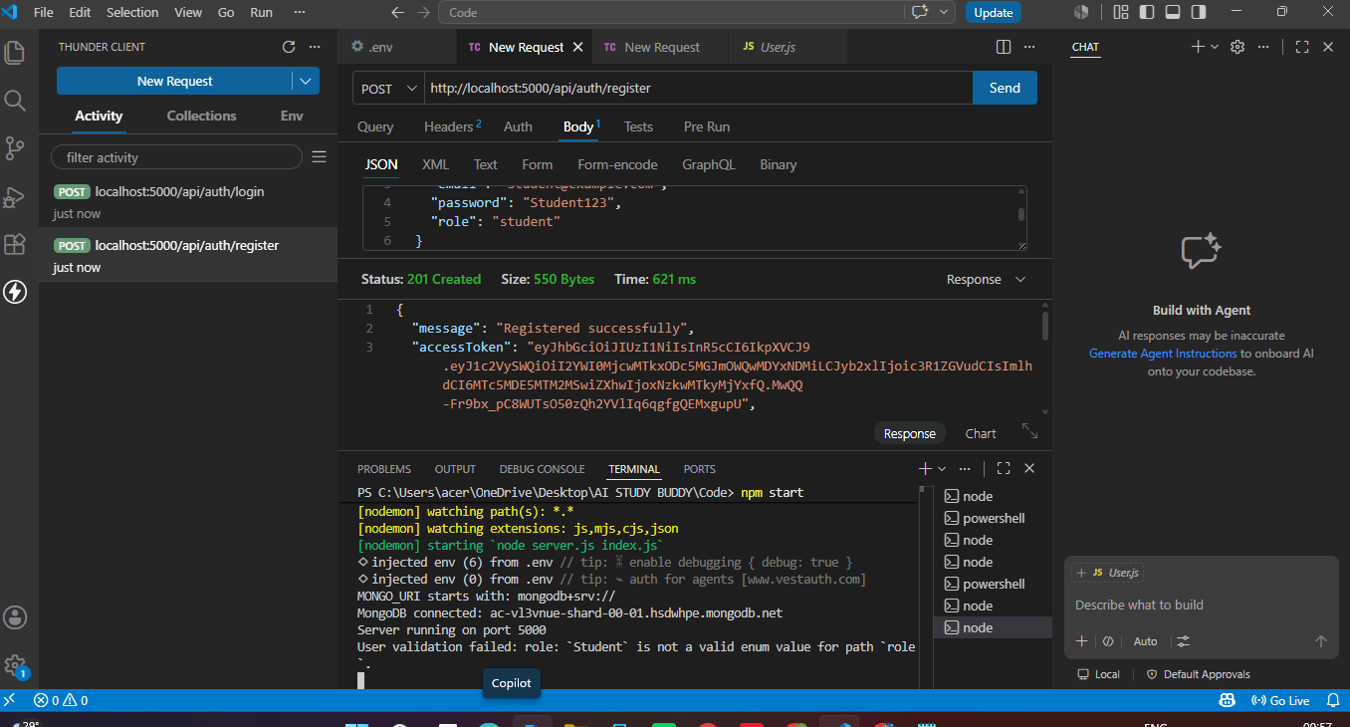
Activity 1.1: Generate a Google Gemini API Key
To enable AI features in the AI StudyBuddy application, a Gemini API key was generated from Google AI Studio and integrated into the project environment.
Steps Executed:
1. Navigated to Google AI Studio (https://aistudio.google.com/) and generated an API key.
2. Configured environment variables in the project's .env file:
GEMINI_API_KEY=your_gemini_api_key_here
PORT=5000
MONGODB_URI=your_mongodb_connection_string
3. Verified initialization in code using @google/generative-ai SDK.

Activity 1.2: Server Setup & Database Connection

Activity 1.2: Server Setup & Database Connection
The Node.js and Express backend server was started and successfully established a connection with MongoDB Atlas.
Terminal Logs:
> npm start
[nodemon] starting `node server.js index.js`
MongoDB connected: ac-vl3vnue-shard-00-01.hsdwhpe.mongodb.net
Server running on port 5000
Activity 2.1: User Authentication API
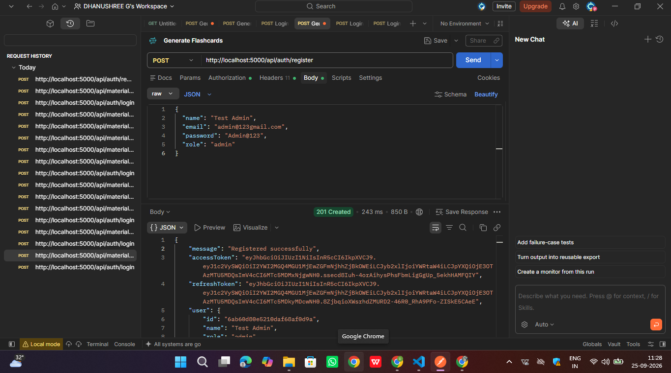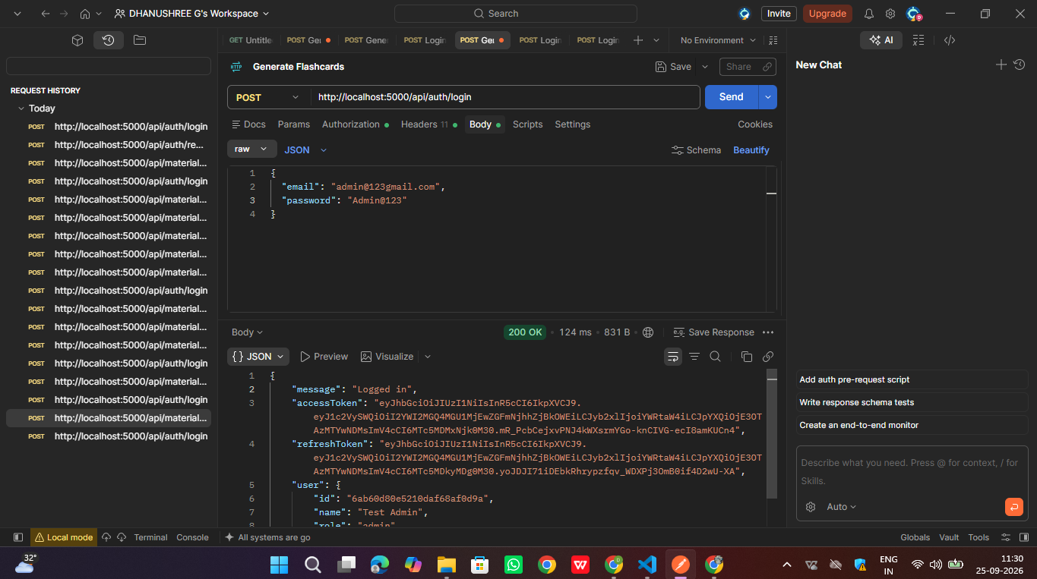
// Endpoint: POST http://localhost:5000/api/auth/register
// Request Body:
{
"name": "Test Admin",
"email": "admin@123gmail.com",
"password": "Admin@123",
"role": "admin"
}

// Response (201 Created):
{
"message": "Registered successfully",
"accessToken": "eyJhbGciOiJIUzI1NiIsInR5cCI6IkXVCJ9...",
"refreshToken": "eyJhbGciOiJIUzI1NiIsInR5cCI6IkXVCJ9...",
"user": {
"id": "6ab60d80e5210daf68af0d9a",
"name": "Test Admin",
"role": "admin"
}
}
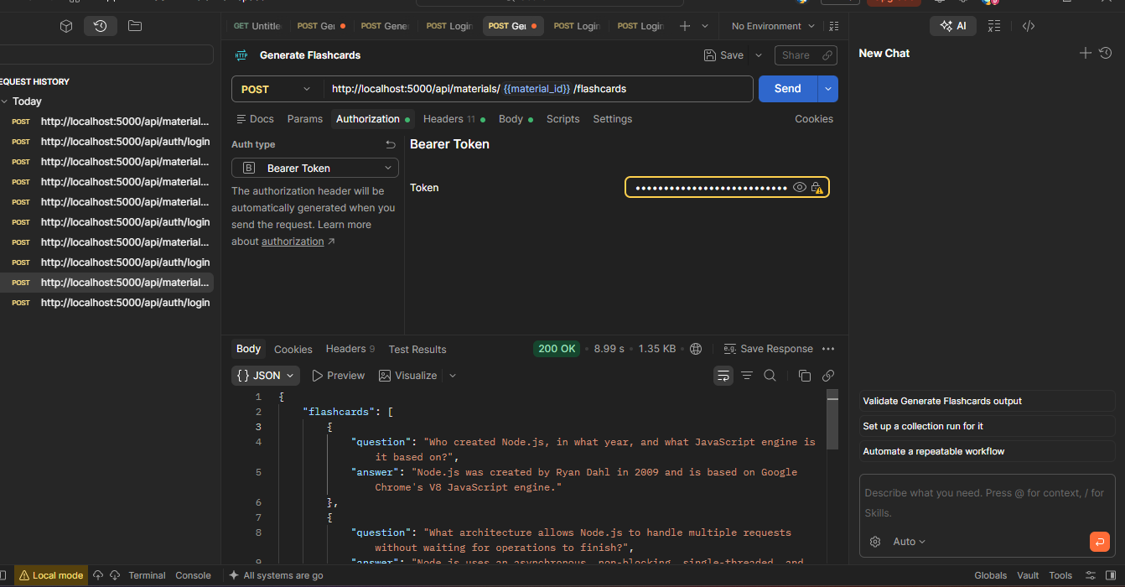
// Endpoint: POST http://localhost:5000/api/materials/{{material_id}}/flashcards
// Headers: Authorization: Bearer <token>

// Response (200 OK):
{
"flashcards": [
{
"question": "Who created Node.js, in what year, and what JavaScript engine is it based on?",
"answer": "Node.js was created by Ryan Dahl in 2009 and is based on Google Chrome's V8 JavaScript engine."
},
{
"question": "What architecture allows Node.js to handle multiple requests without waiting for operations to finish?",
"answer": "Node.js uses an asynchronous, non-blocking single-threaded event loop architecture."
}
]
}

Activity 3.2: Quiz Generation Endpoint
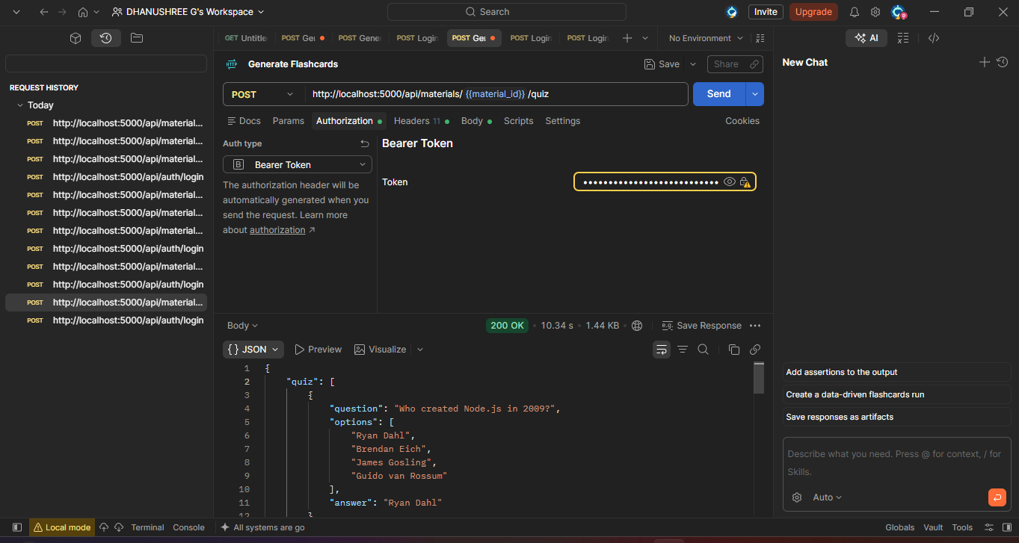
// Endpoint: POST http://localhost:5000/api/materials/{{material_id}}/quiz
// Headers: Authorization: Bearer <token>

// Response (200 OK):
{
"quiz": [
{
"question": "Who created Node.js in 2009?",
"options": [
"Ryan Dahl",
"Brendan Eich",
"James Gosling",
"Guido van Rossum"
],
"answer": "Ryan Dahl"
}
]
}
Activity 3.3: Material Summary Endpoint
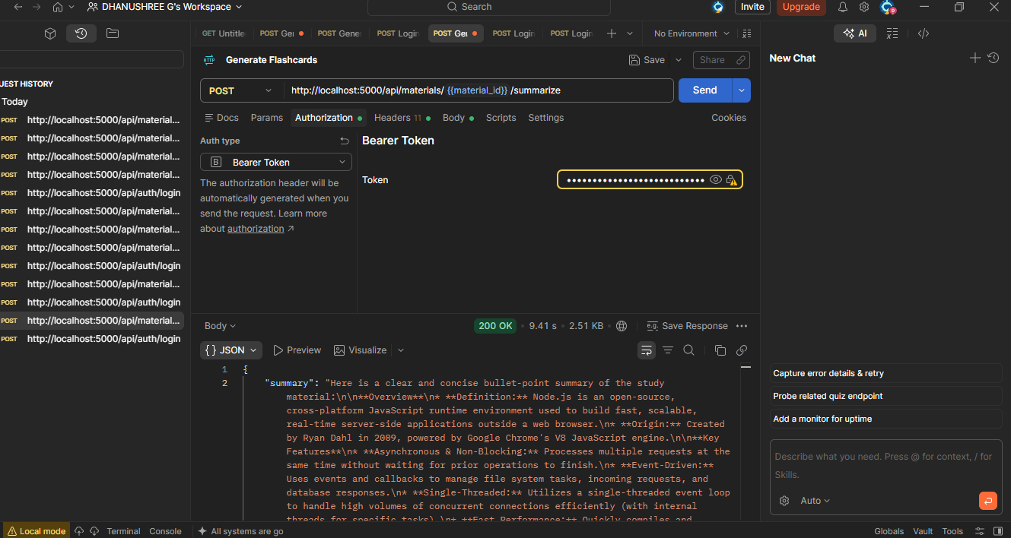
// Endpoint: POST http://localhost:5000/api/materials/{{material_id}}/summarize
// Headers: Authorization: Bearer <token>

// Response (200 OK):
{
"summary": "Here is a clear and concise bullet-point summary of the study material:\n\n**Overview**\n* **Definition:** Node.js is an open-source, cross-platform JavaScript runtime environment used to build fast, scalable, real-time server-side applications outside a web browser.\n* **Origin:** Created by Ryan Dahl in 2009, powered by Google Chrome's V8 JavaScript engine.\n\n**Key Features**\n* **Asynchronous & Non-Blocking:** Processes multiple requests at the same time without waiting for prior operations to finish.\n* **Event-Driven:** Uses events and callbacks to manage file system tasks, incoming requests, and database responses.
}
Activity 3.4: Study Plan Generator Endpoint
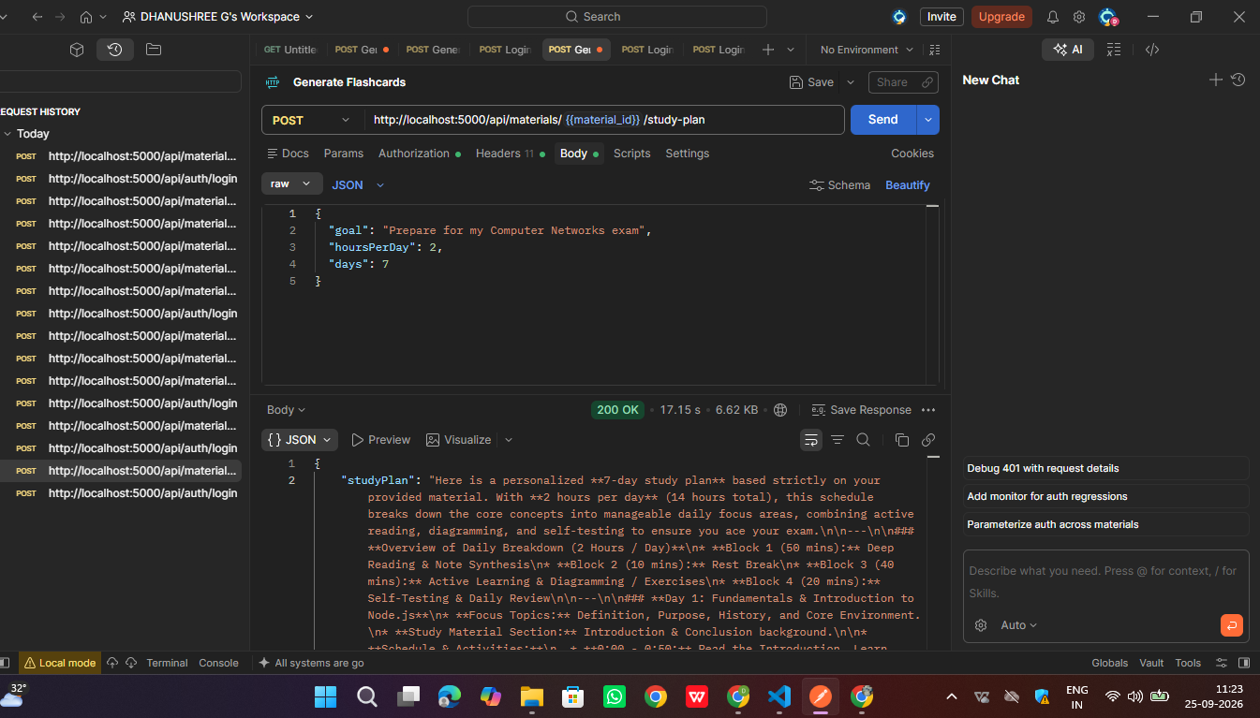
// Endpoint: POST http://localhost:5000/api/materials/{{material_id}}/study-plan
// Request Body:
{
"goal": "Prepare for my Computer Networks exam",
"hoursPerDay": 2,
"days": 7
}

// Response (200 OK):
{
"studyPlan": "Here is a personalized **7-day study plan** based strictly on your provided material. With **2 hours per day** (14 hours total), this schedule breaks down the core concepts into manageable daily focus areas..."
}
Activity 4.1: Admin User Management
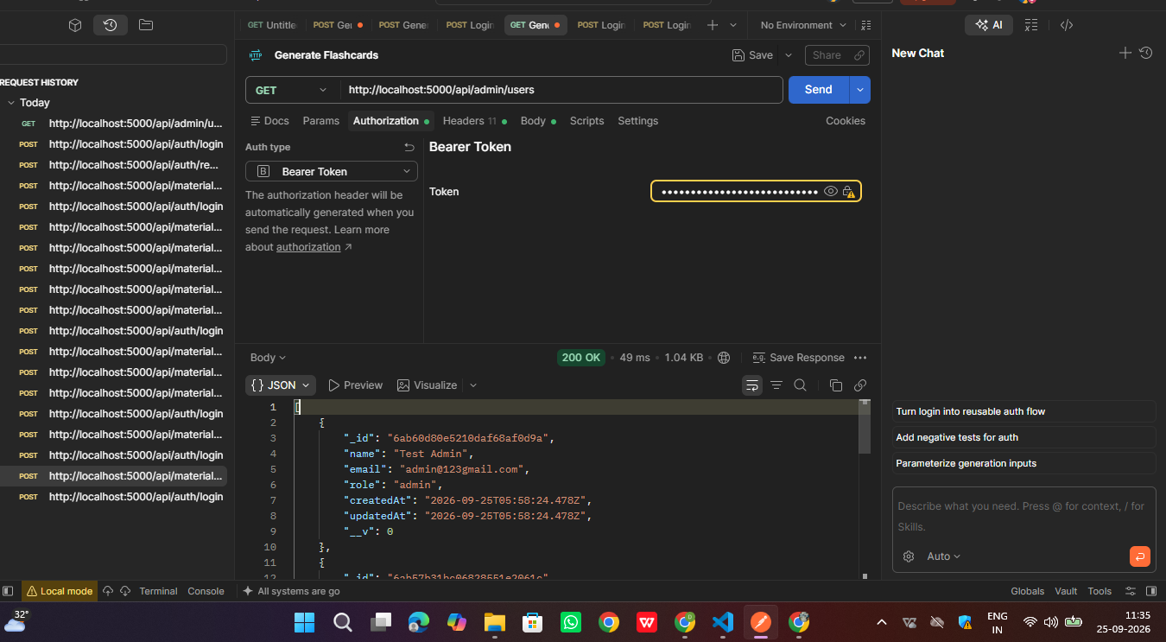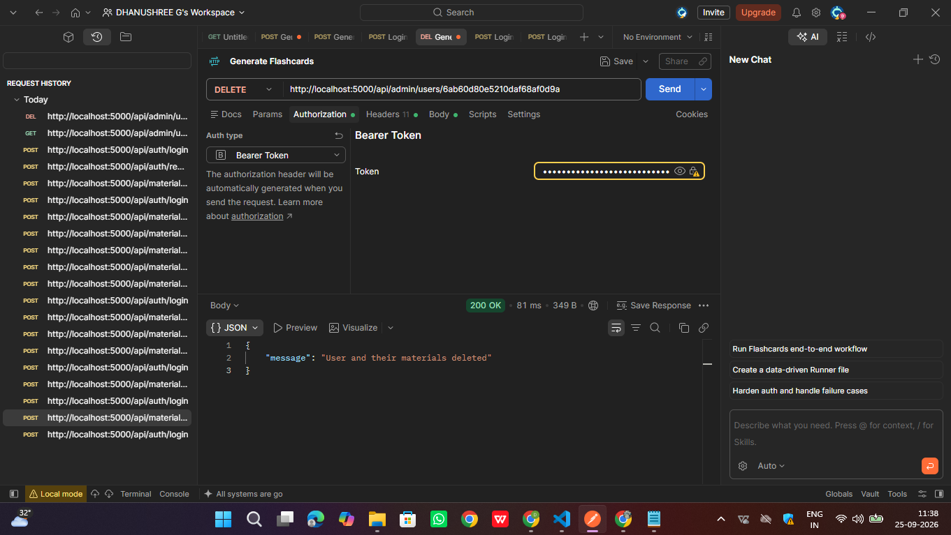
// Endpoint: DELETE http://localhost:5000/api/admin/users/6ab60d80e5210daf68af0d9a
// Headers: Authorization: Bearer <admin_token>

// Response (200 OK):
{
"message": "User and their materials deleted"
}

